**Implementation and Testing Unit**

Dan Kelsey

**IT5 – Arrays**

An array in a program, and a function that uses the array

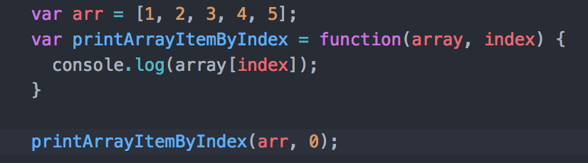

The result of the function running

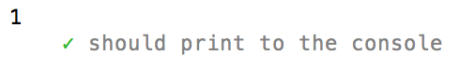

**IT6 – Hashes**

A hash in a program, and a function that uses the hash

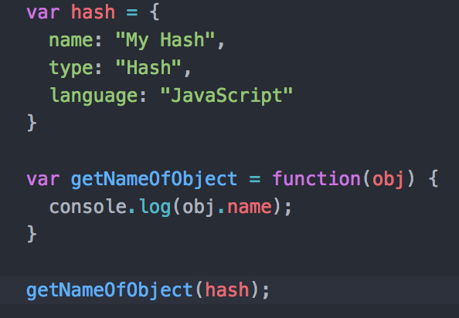

The result of the function running

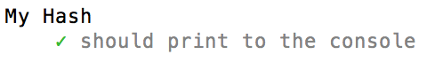

**IT3 – Searching**

A function that searches data

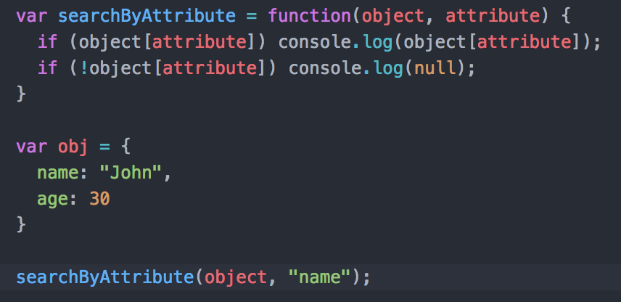

The result of the function running

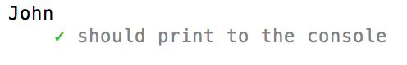

**IT4 – Sorting**

A function that sorts data

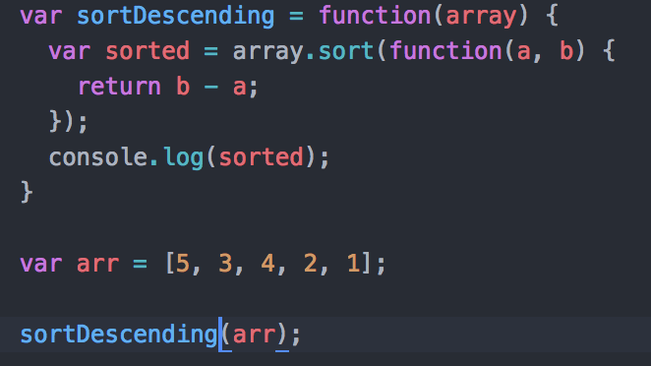

The result of the function running



**IT7 – Polymorphism**

Polymorphism in a program:

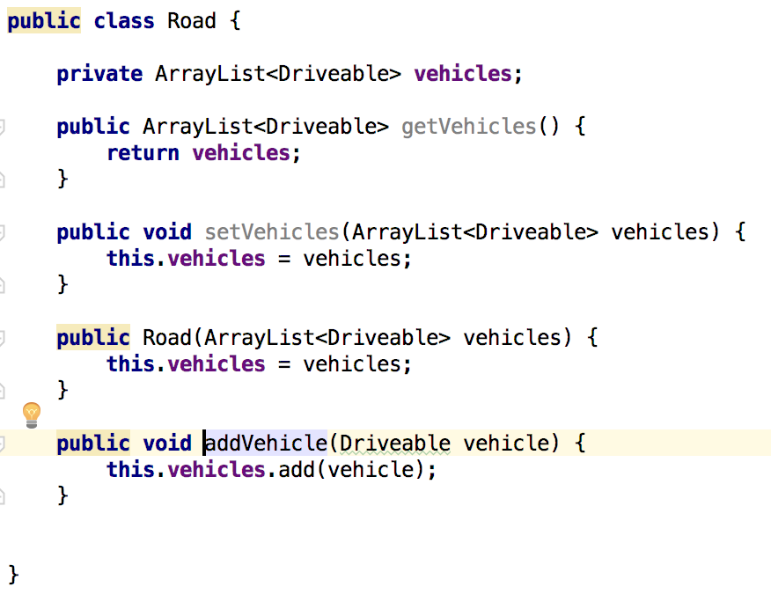

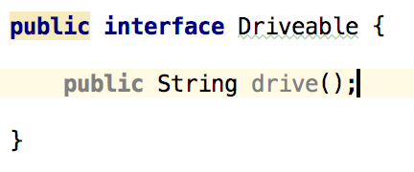

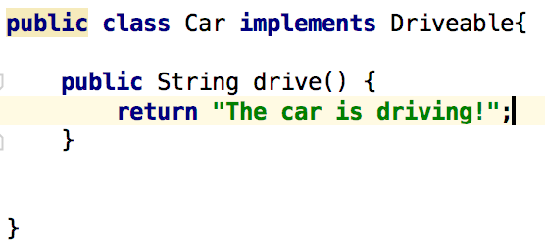

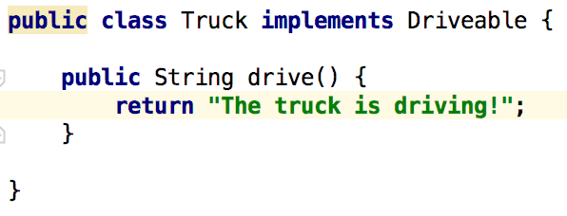

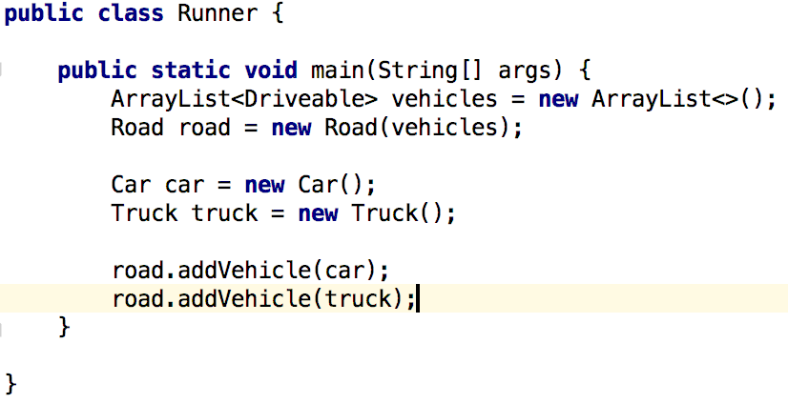

**IT1 – Encapsulation**

Encapsulation in a program

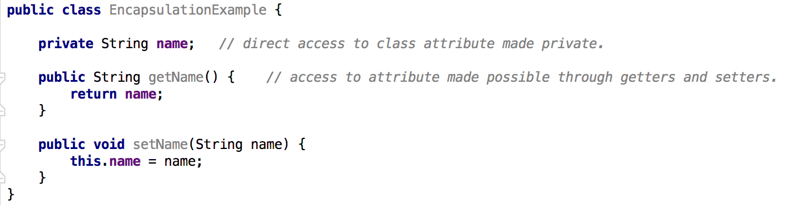

**IT2 – Inheritance**

A class:

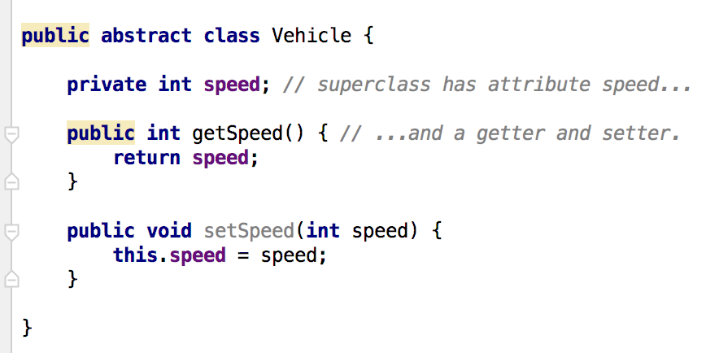

A class that inherits from the previous class

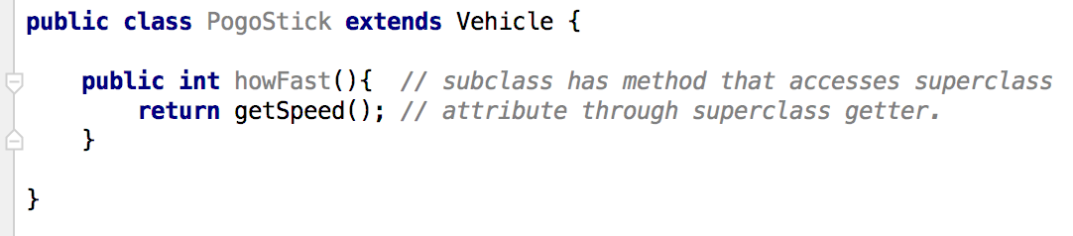

An object of the subclass’s method which uses information from the inherited class:

